**SPRING REST HANDSON (2)**

**Exercise 02 : Hello World RESTful Web Service**   
  
Write a REST service in the spring learn application created earlier, that returns the text "Hello World!!" using Spring Web Framework. Refer details below:  
  
**Method:** GET  
**URL:** /hello  
**Controller:** com.cognizant.spring-learn.controller.HelloController  
**Method Signature:** public String sayHello()  
**Method Implementation:** return hard coded string "Hello World!!"  
**Sample Request**: http://localhost:8083/hello  
**Sample Response:** Hello World!!   
  
**IMPORTANT NOTE**: Don't forget to include start and end log in the sayHello() method.  
  
Try the URL http://localhost:8083/hello in both chrome browser and postman.  
  
SME to explain the following aspects:

* In network tab of developer tools show the HTTP header details received
* In postman click on "Headers" tab to view the HTTP header details received

**Code:**

**Pom.xml**

<project *xmlns*="http://maven.apache.org/POM/4.0.0"

*xmlns:xsi*="http://www.w3.org/2001/XMLSchema-instance"

*xsi:schemaLocation*="http://maven.apache.org/POM/4.0.0

                             http://maven.apache.org/xsd/maven-4.0.0.xsd">

    <modelVersion>4.0.0</modelVersion>

    <groupId>com.example</groupId>

    <artifactId>spring-rest-demo</artifactId>

    <version>0.0.1-SNAPSHOT</version>

    <packaging>jar</packaging>

    <name>spring-rest-demo</name>

    <properties>

        <java.version>17</java.version>

        <spring.boot.version>3.2.4</spring.boot.version>

    </properties>

    <dependencies>

*<!-- ✅ Spring Boot Web Starter -->*

        <dependency>

            <groupId>org.springframework.boot</groupId>

            <artifactId>spring-boot-starter-web</artifactId>

            <version>${spring.boot.version}</version>

        </dependency>

*<!-- ✅ Spring Boot Starter Test (optional) -->*

        <dependency>

            <groupId>org.springframework.boot</groupId>

            <artifactId>spring-boot-starter-test</artifactId>

            <version>${spring.boot.version}</version>

            <scope>test</scope>

        </dependency>

    </dependencies>

    <build>

        <plugins>

*<!-- ✅ Spring Boot Maven Plugin -->*

            <plugin>

                <groupId>org.springframework.boot</groupId>

                <artifactId>spring-boot-maven-plugin</artifactId>

                <version>${spring.boot.version}</version>

            </plugin>

        </plugins>

    </build>

</project>

**SpringRestDemoApllication.java**

**package** **com.example**;

**import** **org.springframework.boot.SpringApplication**;

**import** **org.springframework.boot.autoconfigure.SpringBootApplication**;

@**SpringBootApplication**

**public** **class** SpringRestDemoApplication {

**public** **static** **void** main(**String**[] args) {

        SpringApplication.run(SpringRestDemoApplication.class, args);

    }

}

**HelloController.java**

**package** **com.example.controller**;

**import** **org.slf4j.Logger**;

**import** **org.slf4j.LoggerFactory**;

**import** **org.springframework.web.bind.annotation.\***;

@**RestController**

**public** **class** HelloController {

**private** **static** **final** **Logger** LOGGER **=** LoggerFactory.getLogger(HelloController.class);

    @**GetMapping**("/hello")

**public** **String** sayHello() {

        LOGGER.info("START sayHello()");

**String** message **=** "Hello World!!";

        LOGGER.info("END sayHello()");

**return** message;

    }

}

**Application.properties**

*# Optional: Run on specific port*

server.port=8083

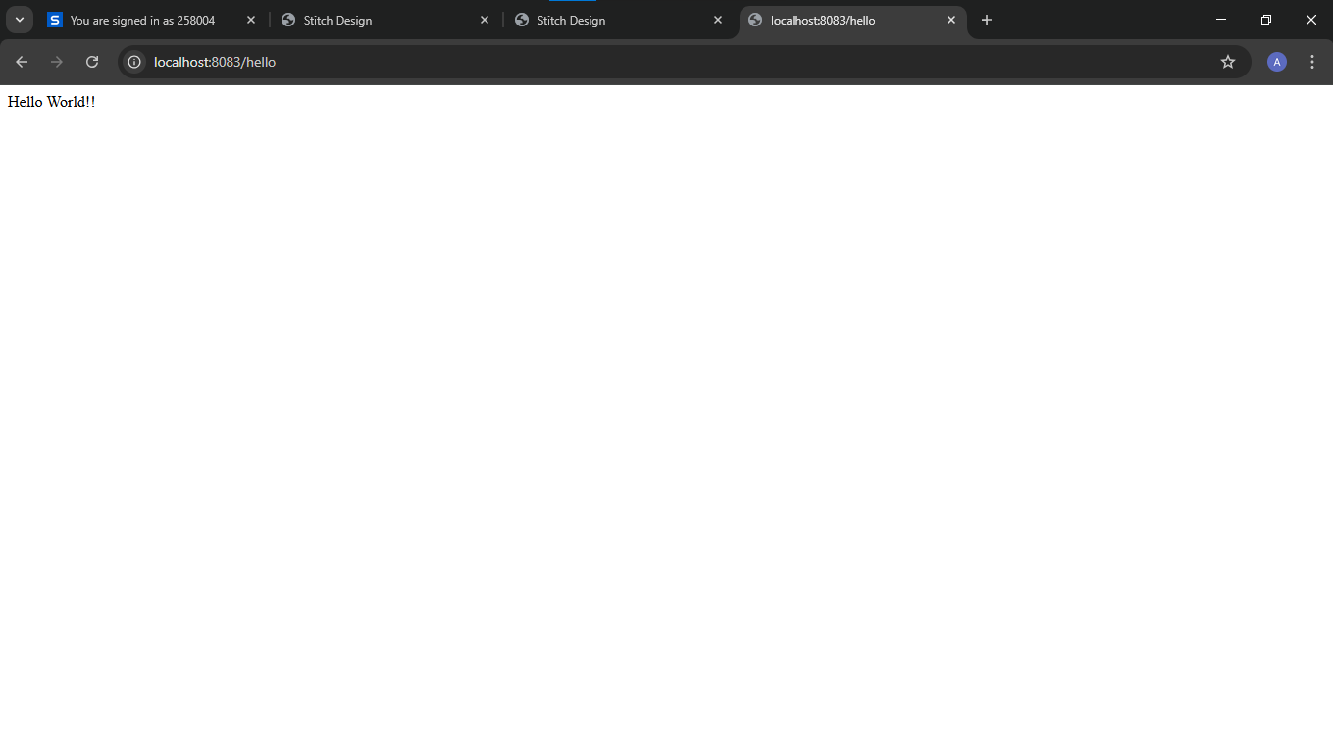**Output:**

**Exercise 02 : REST - Country Web Service**   
  
Write a REST service that returns India country details in the earlier created spring learn application.  
  
**URL**: /country  
**Controller**: com.cognizant.spring-learn.controller.CountryController  
**Method Annotation**: @RequestMapping  
**Method Name**: getCountryIndia()  
**Method Implementation**: Load India bean from spring xml configuration and return  
**Sample Request**: http://localhost:8083/country  
**Sample Response**:

{

  "code": "IN",

  "name": "India"

}

SME to explain the following aspects:

* What happens in the controller method?
* How the bean is converted into JSON reponse?
* In network tab of developer tools show the HTTP header details received
* In postman click on "Headers" tab to view the HTTP header details received

**Code:**

**Country.java**

**package** **com.example.model**;

**public** **class** Country {

**private** **String** code;

**private** **String** name;

*// Getters and Setters*

**public** **String** getCode() {

**return** code;

    }

**public** **void** setCode(**String** code) {

        this.code **=** code;

    }

**public** **String** getName() {

**return** name;

    }

**public** **void** setName(**String** name) {

        this.name **=** name;

    }

}

**Country.xml**

<?xml *version*="1.0" *encoding*="UTF-8"?>

<beans *xmlns*="http://www.springframework.org/schema/beans"

*xmlns:xsi*="http://www.w3.org/2001/XMLSchema-instance"

*xsi:schemaLocation*="

         http://www.springframework.org/schema/beans

         http://www.springframework.org/schema/beans/spring-beans.xsd">

    <bean *id*="in" *class*="com.example.model.Country">

        <property *name*="code" *value*="IN" />

        <property *name*="name" *value*="India" />

    </bean>

</beans>

**ControllerCountry.java**

**package** **com.example.controller**;

**import** **org.springframework.context.ApplicationContext**;

**import** **org.springframework.context.support.ClassPathXmlApplicationContext**;

**import** **org.springframework.web.bind.annotation.GetMapping**;

**import** **org.springframework.web.bind.annotation.RestController**;

**import** **com.example.model.Country**;

@**RestController**

**public** **class** CountryController {

    @**GetMapping**("/country")

**public** **Country** getCountryIndia() {

**ApplicationContext** context **=** **new** ClassPathXmlApplicationContext("country.xml");

**return** context.getBean("in", Country.class);

    }

}

**Output:**

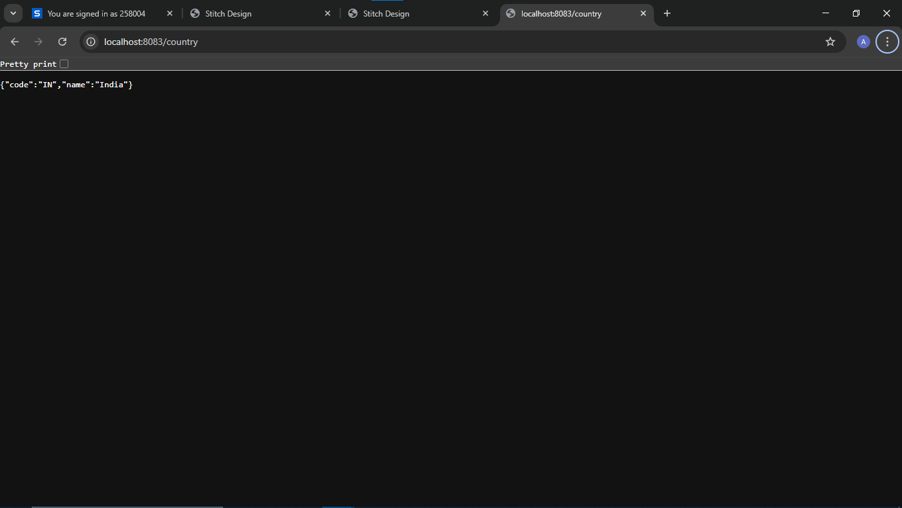

**Exercise 04 : REST - Get country based on country code**   
  
Write a REST service that returns a specific country based on country code. The country code should be case insensitive.  
  
**Controller**: com.cognizant.spring-learn.controller.CountryController  
**Method Annotation:** @GetMapping("/countries/{code}")  
**Method Name**: getCountry(String code)  
**Method Implemetation**: Invoke countryService.getCountry(code)   
**Service Method:**com.cognizant.spring-learn.service.CountryService.getCountry(String code)  
  
**Service Method Implementation**:

* Get the country code using @PathVariable
* Get country list from country.xml
* Iterate through the country list
* Make a case insensitive matching of country code and return the country.
* Lambda expression can also be used instead of iterating the country list

**Sample Request**: http://localhost:8083/country/in  
  
**Sample Response**:

{

  "code": "IN",

  "name": "India"

}

**Code:**

**CountryService.java**

**package** **com.example.service**;

**import** **java.util.List**;

**import** **org.springframework.context.ApplicationContext**;

**import** **org.springframework.context.support.ClassPathXmlApplicationContext**;

**import** **org.springframework.stereotype.Service**;

**import** **com.example.exception.CountryNotFoundException**;

**import** **com.example.model.Country**;

@**Service**

**public** **class** CountryService {  *// ✅ class wrapper added*

**public** **Country** getCountry(**String** code) **throws** **CountryNotFoundException** {

**ApplicationContext** context **=** **new** ClassPathXmlApplicationContext("country.xml");

**List**<**Country**> countries **=** (**List<**Country**>**) context.getBean("countryList");

**return** countries.stream()

                .filter(c **->** c.getCode().equalsIgnoreCase(code))

                .findFirst()

                .orElseThrow(() **->** **new** CountryNotFoundException("Country not found: " **+** code));

    }

**public** **List**<**Country**> getAllCountries() {

**ApplicationContext** context **=** **new** ClassPathXmlApplicationContext("country.xml");

**return** (**List<**Country**>**) context.getBean("countryList");

    }

}

**CountryController.java**

**package** **com.example.controller**;

**import** **com.example.model.Country**;

**import** **com.example.service.CountryService**;

**import** **com.example.exception.CountryNotFoundException**;

**import** **org.springframework.beans.factory.annotation.Autowired**;

**import** **org.springframework.web.bind.annotation.\***;

**import** **java.util.List**;

@**RestController**

**public** **class** CountryController {

    @**Autowired**

**private** **CountryService** countryService;

    @**GetMapping**("/country")

**public** **Country** getCountryIndia() {

**return** **new** Country("IN", "India");  *// hardcoded for /country*

    }

    @**GetMapping**("/countries")

**public** **List**<**Country**> getAllCountries() {

**return** countryService.getAllCountries();  *// if you've added this*

    }

    @**GetMapping**("/countries/{code}")

**public** **Country** getCountryByCode(@**PathVariable** **String** code) **throws** **CountryNotFoundException** {

**return** countryService.getCountry(code);

    }

}

**CountryNotFoundException.java**

**package** **com.example.exception**;

**import** **org.springframework.http.HttpStatus**;

**import** **org.springframework.web.bind.annotation.ResponseStatus**;

@**ResponseStatus**(value **=** HttpStatus.NOT_FOUND, reason **=** "Country not found")

**public** **class** CountryNotFoundException **extends** Exception {

**public** CountryNotFoundException(**String** message) {

        super(message);

    }

}

**Country.xml**

<?xml *version*="1.0" *encoding*="UTF-8"?>

<beans *xmlns*="http://www.springframework.org/schema/beans"

*xmlns:xsi*="http://www.w3.org/2001/XMLSchema-instance"

*xsi:schemaLocation*="

         http://www.springframework.org/schema/beans

         https://www.springframework.org/schema/beans/spring-beans.xsd">

    <bean *id*="in" *class*="com.example.model.Country">

        <property *name*="code" *value*="IN" />

        <property *name*="name" *value*="India" />

    </bean>

    <bean *id*="countryList" *class*="java.util.ArrayList">

        <constructor-arg>

            <list>

                <ref *bean*="in"/>

                <bean *class*="com.example.model.Country">

                    <property *name*="code" *value*="US"/>

                    <property *name*="name" *value*="United States"/>

                </bean>

                <bean *class*="com.example.model.Country">

                    <property *name*="code" *value*="JP"/>

                    <property *name*="name" *value*="Japan"/>

                </bean>

                <bean *class*="com.example.model.Country">

                    <property *name*="code" *value*="DE"/>

                    <property *name*="name" *value*="Germany"/>

                </bean>

            </list>

        </constructor-arg>

    </bean>

</beans>

**Country.java**

**package** **com.example.model**;

**public** **class** Country {

**private** **String** code;

**private** **String** name;

**public** Country() {}  *// default constructor*

**public** Country(**String** code, **String** name) {  *// ✅ fix*

        this.code **=** code;

        this.name **=** name;

    }

**public** **String** getCode() {

**return** code;

    }

**public** **void** setCode(**String** code) {

        this.code **=** code;

    }

**public** **String** getName() {

**return** name;

    }

**public** **void** setName(**String** name) {

        this.name **=** name;

    }

}

**Output:**

